**Chapter 7 - Inheritance**

**All Lectures Uploaded on YouTube:**

[**https://tinyurl.com/fkm10-biology**](https://tinyurl.com/fkm10-biology)

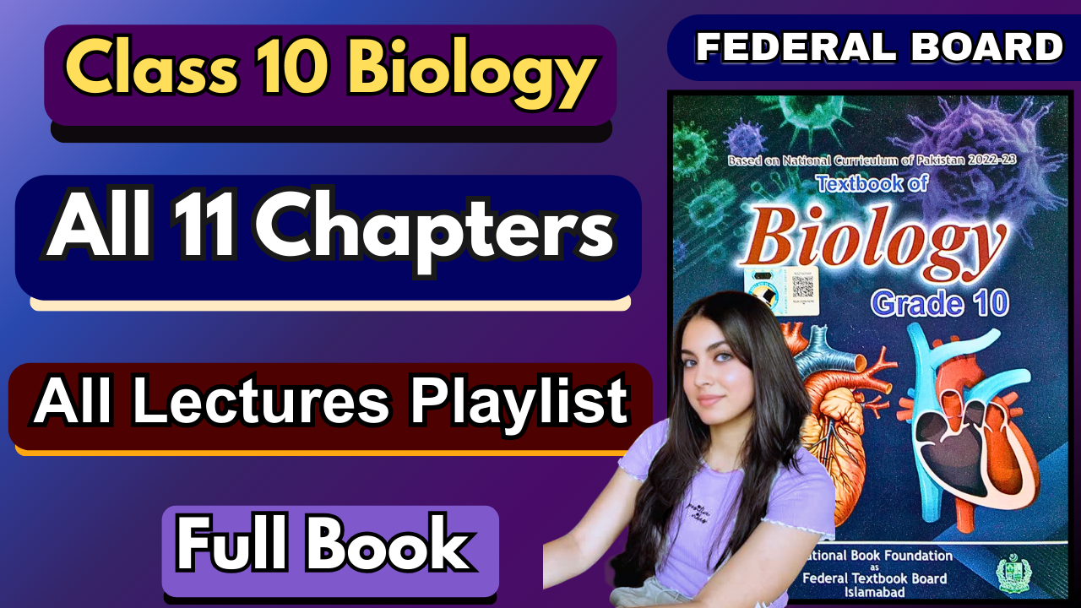

* Inheritance is the process by which traits are passed from parents to offspring.
* Traits may be **similarities** or **differences** (variation) between parents and offspring.
* **Gregor Mendel’s** experiments with pea plants revealed the principles of genetics.
* Traits are controlled by **genes**, which can be **dominant** or **recessive**, and are inherited in **predictable patterns**.

## **7.1. Structure of Chromosome**

### **Chromosomes**

* Thread-like structures in the nucleus of cells.
* Made of **DNA (Deoxyribonucleic Acid)** and proteins.
* During interphase, they are present as **chromatin** (thin fibrous network).
* DNA carries genetic information for development, functioning, and reproduction.

### **7.1.1. Parts of a Chromosome**

A chromosome has three main parts: **chromatids, the centromere, and the telomeres**.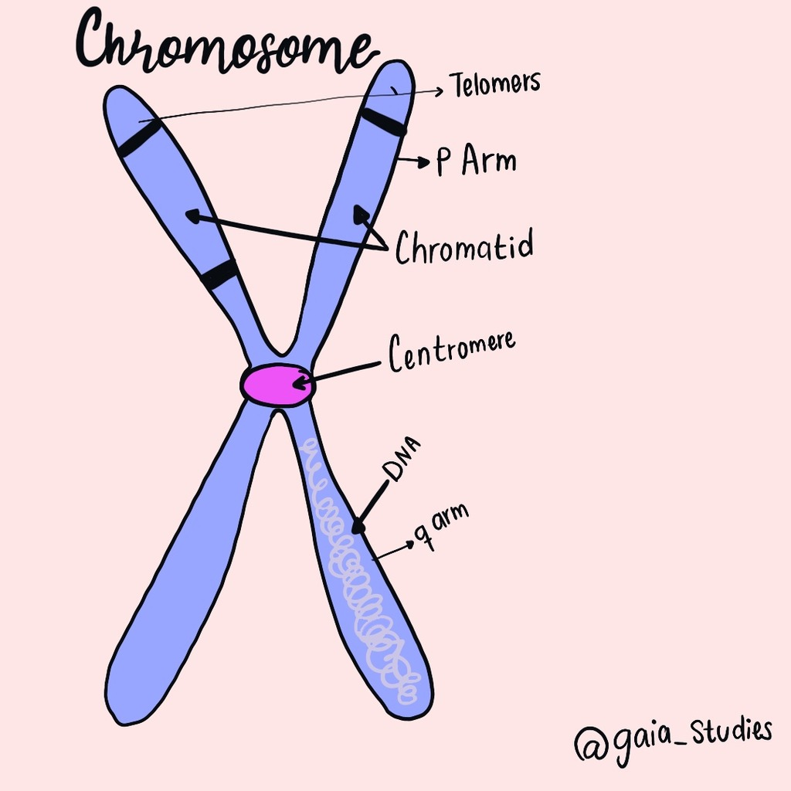

1. **Chromatids**
   * Before DNA replication (S-phase): one thread-like structure = single chromatid.
   * After replication, a chromosome consists of **two identical sister chromatids** joined at the centromere.
   * Sister chromatids = duplicated copies of the chromosome.
2. **Centromere**
   * Constricted region where sister chromatids attach.
   * Has a protein complex called a **kinetochore**, which helps spindle fibres attach during **mitosis** and **meiosis**.
   * Ensures equal distribution of chromosomes into daughter cells.
3. **Telomeres**
   * End regions of chromosomes.
   * Prevent degradation and loss of important genetic information during cell division.

## **7.2. Genotypes and Phenotypes**

* Understanding inheritance requires knowledge of terms like **gene, allele, genotype, phenotype, and gene pool**.
* These explain how traits are inherited and expressed in organisms.

### **7.2.1. Genes, Alleles, and Loci**

#### **i) Genes**

* A **gene** = unit of inheritance.
* It is a **specific segment of DNA** (a unique nucleotide sequence) that codes for a particular **polypeptide/protein**.
* Each characteristic of the body is controlled by **factor(s)** called genes.
* Mendel first proposed the idea of “gene,” calling them “factors.”
* Genes are represented by **alphabetical symbols**.
* Parental traits are passed to offspring via genes.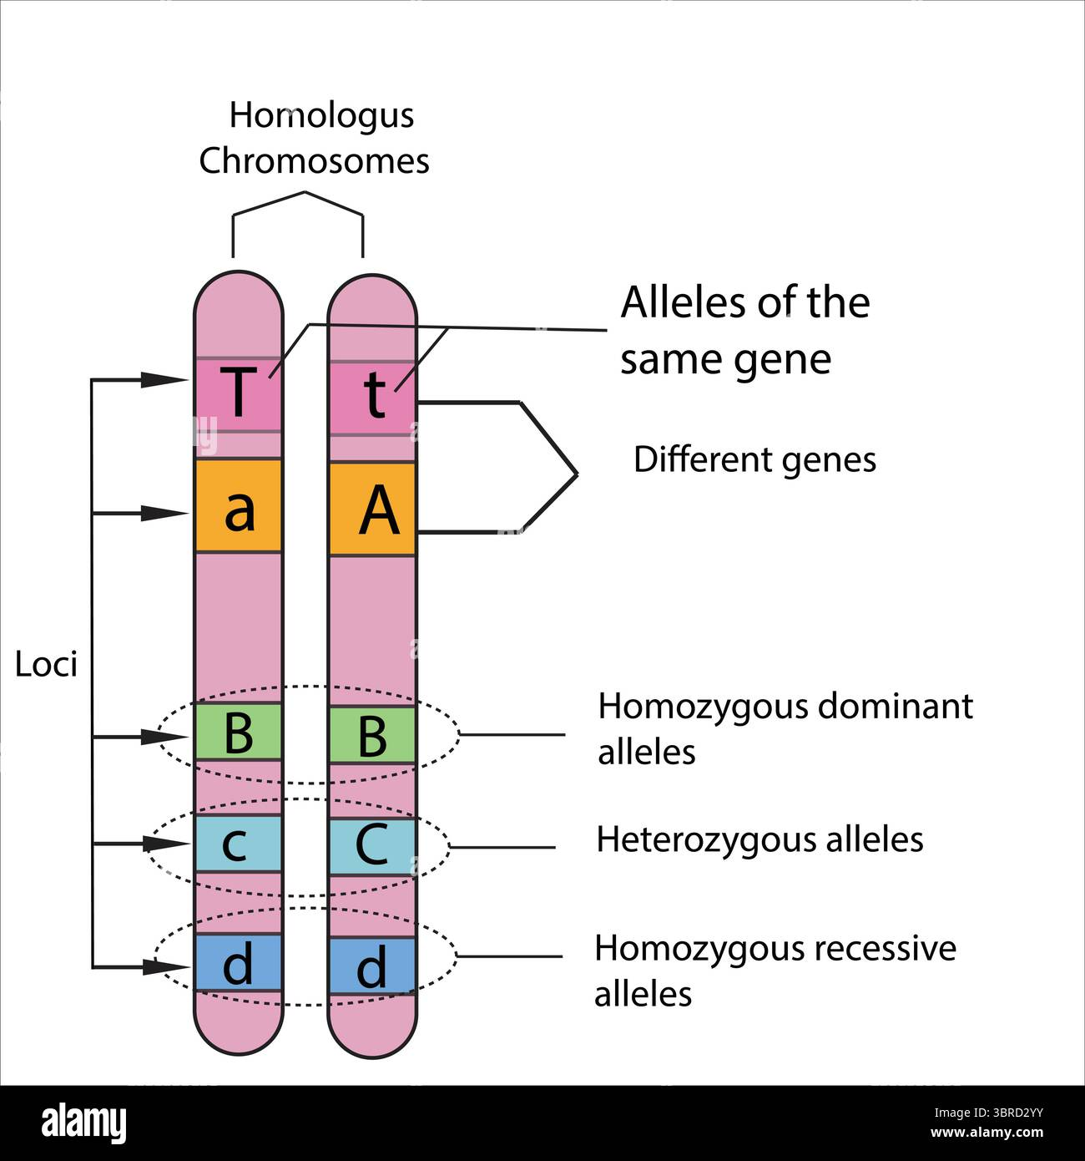

#### **ii) Locus (plural: Loci)**

* Genes are found on **chromosomes** at specific positions called **loci**.
* A locus is present on both members of a **homologous pair of chromosomes**
* The **genome** = complete set of an individual’s genes.
* Genome = set of chromosomes carrying genetic information, represented by “n” (haploid).
* Cells with **two sets of chromosomes** = diploid (2n)
* In humans: genome = 23 chromosomes (haploid), 46 in diploid cells.
* Gametes (sperm/egg) contain a haploid number, somatic (body) cells contain a diploid number.

**iii) Allele**

* A gene can exist in two or more forms, called **alleles**.
* Alleles are versions of the same gene that occupy the same position (locus) on a chromosome.
* Example in humans:
  + **E** = free earlobes
  + **e** = attached earlobes
* Both "E" and "e" are located at the same locus and are **alleles of each other**.
* Even though "E" and "e" are different, they are both considered **alleles**.

### **Homozygous and Heterozygous**

* **Homozygous**: Both alleles are the same (e.g., AA or aa).
* **Heterozygous**: Alleles are different (e.g., Aa).
* **Dominant allele**: Expressed in both homozygous and heterozygous condition
* **Recessive allele**: Expressed only in a homozygous condition.

### **7.2.2. Genotype and Phenotypes**

#### **i) Genotype**

* The genetic makeup of a trait at each locus is called the **genotype**.
* It usually consists of a pair of genes (alleles).
* Example:
  + **EE** or **Ee** = free earlobes
  + **ee** = attached earlobes
* If both alleles are **same** (EE, ee) → **Homozygous**
* If alleles are **different** (Ee) → **Heterozygous**
* **Homozygous individuals** = "True breed" → always produce the same offspring if self-fertilised.
* **Heterozygous individuals** = "Non-true breed" → can produce offspring with variation.

Examples from pea plants:

* **RR (pure round)** × self → always round seeds.
* **Rr (non-pure round)** × self → round + wrinkled seeds.

#### **ii) Phenotype**

* The **physical appearance** of a trait is called the phenotype.
* Determined by genotype.
* Example:
  + EE or Ee = free earlobes (dominant)
  + ee = attached earlobes (recessive)
* Phenotype is visible, even if the organism carries hidden (recessive) genes.
* **Dominant phenotype** = appears in both homozygous (EE) and heterozygous (Ee).
* **Recessive phenotype** = appears only in homozygous condition (ee).
* Representation:
  + Dominant allele → capital letter (E)
  + Recessive allele → small letter (e)

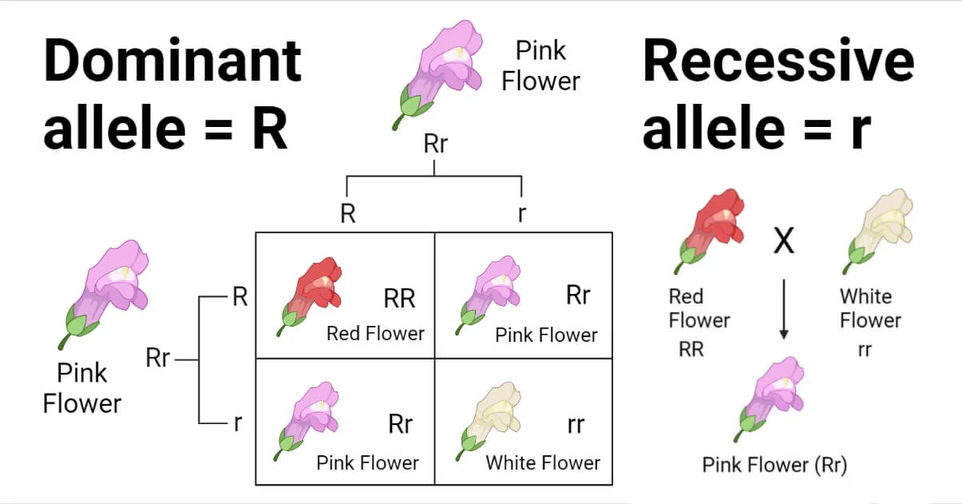

**Self-Fertilisation**

* A type of reproduction where an organism’s own sperm fertilises its own eggs.
* Common in plants and hermaphroditic animals.
* Produces offspring genetically identical to the parent (less variation).
* Leads to **true-breeding plants** after repeated generations of self-fertilisation.

## **7.3. Mendelian Inheritance**

* Rediscovered in **1900**, originally studied by **Gregor Johann Mendel** in **1866**.
* Mendel is called the **Father of Genetics**.
* He explained how traits pass from generation to generation through pea plant experiments.
* His principle of inheritance is called **Mendelian Inheritance**.

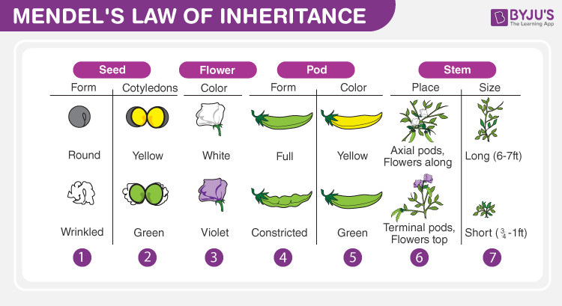

### 

### **Mendel’s Experiment**

* Developed **true-breeding plants** through repeated self-fertilisation.
* Worked with **seven pairs of contrasting traits** in pea plants.

### **Hybridization**

* Mendel cross-fertilised plants with different traits.
* Example:
  + Round-seed plant × Wrinkled-seed plant (monohybrid cross).
  + Round, yellow-seed plant × Wrinkled, green-seed plant (dihybrid cross).
* These experiments helped explain **dominance, recessiveness, and segregation of traits**.

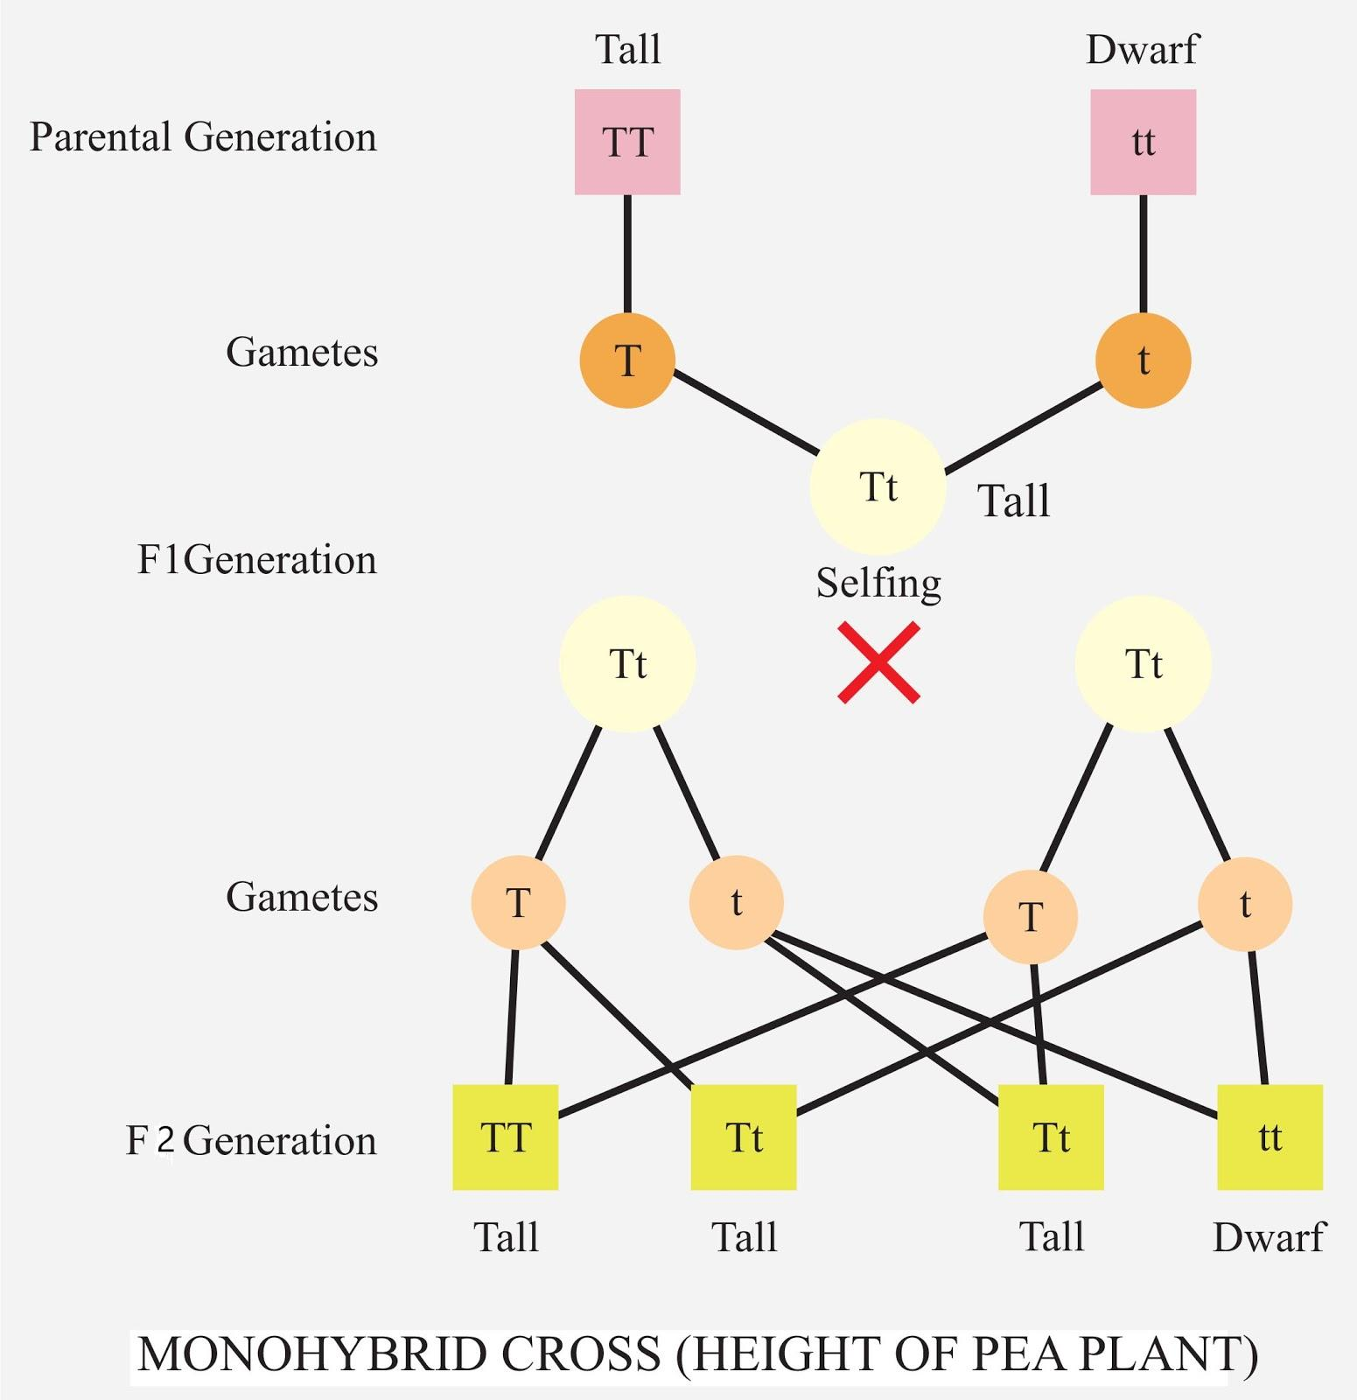

## **7.3.1. Inheritance of a Single Trait by Monohybrid Cross**

* A **monohybrid cross** involves the study of the inheritance of a single trait (e.g., seed shape).
* Mendel crossed two plants differing in **one trait**.

### **Mendel’s Procedure & Observations**

1. **Parental Cross (P1 Generation):**
   * True-breeding round seed plant (RR) × True-breeding wrinkled seed plant (rr).
   * True breed is always homozygous
   * Gametes: R and r.
   * **F1 Generation:** All offspring (Rr) → round seeds (round is dominant).
2. **Self-fertilisation of F1:**
   * F1 (Rr × Rr).
   * **F2 Generation ratio:**
     + **Phenotype ratio:** 3 round: 1 wrinkled.
     + **Genotype ratio:** 1 RR: 2 Rr: 1 rr.
   * Thus, 25% true-breed round (RR), 50% heterozygous round (Rr), 25% wrinkled (rr).

### **Conclusion / Interpretation of Results**

Mendel concluded:

1. Traits are controlled by **factors (genes)** passed from parents to offspring.  
   Each plant carries **two alleles** for each trait (one from each parent).
2. **Dominant alleles** (R) are expressed, while **recessive alleles** (r) are hidden in F1 but reappear in F2.
3. During **gamete formation**, alleles segregate independently into different gametes.
4. The gene pair is **restored** upon fertilisation.

### **Law of Segregation**

* In monohybrid crosses, **alleles of a gene pair segregate** during gamete formation (meiosis) and recombine randomly during fertilisation.

## **7.3.2. Inheritance of Two Traits by Dihybrid Cross**

A **dihybrid cross** involves the study of inheritance of **two traits simultaneously** (e.g., seed shape and seed color).

### **Mendel’s Procedure & Observations**

1. **Parental Cross (P1 Generation):**
   * True-breeding round yellow (RRYY) × True-breeding wrinkled green (rryy).
   * **F1 Generation:** All offspring (RrYy) → round yellow (dominant traits).
2. **Self-fertilization of F1 (RrYy × RrYy):**
   * Mendel expected a 3:1 ratio (like in monohybrid), but observed a **9:3:3:1 ratio**.
3. **F2 Generation combinations:**
   * Round yellow:9
   * Round green:3
   * Wrinkled yellow:3
   * Wrinkled green:1

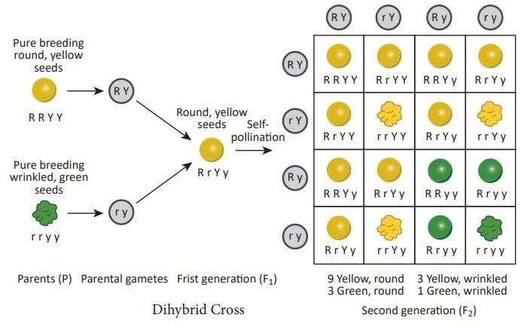

### **Conclusion / Interpretation of Results**

* New combinations appeared (e.g., round green, wrinkled yellow).
* Mendel concluded:
  1. Alleles of one gene pair (R and r) **assort independently** of the alleles of another gene pair (Y and y).
  2. This is called the **Law of Independent Assortment**.
  3. F1 individuals (RrYy) produced gametes in equal proportions: RY, Ry, rY, ry.

